**Name:Mansi Jumde**

**Class:A3**

**Batch:B1**

**Roll no.:09**

**DAA LAB**

**Practical -7**

**Geeks for Geeks**

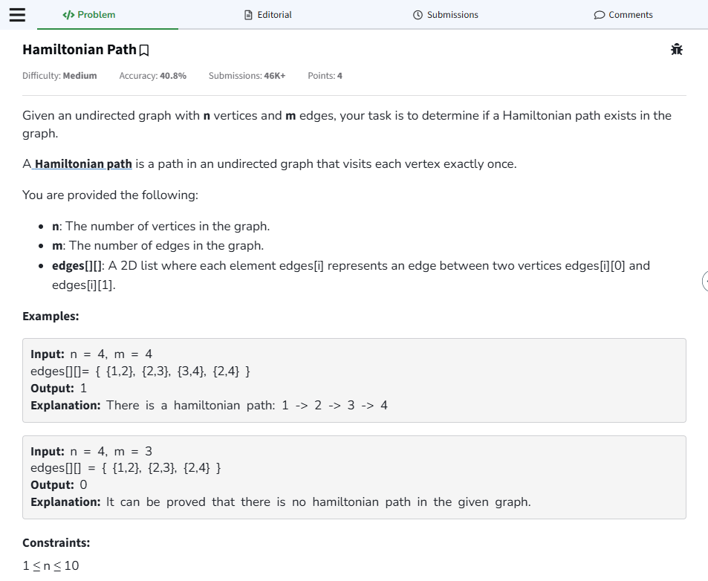

[**https://www.geeksforgeeks.org/problems/hamiltonian-path2522/1**](https://www.geeksforgeeks.org/problems/hamiltonian-path2522/1)

